CUSP Music
Curriculum context:
Curriculum statement: (School adds own brief curriculum statement which reflects the school context)

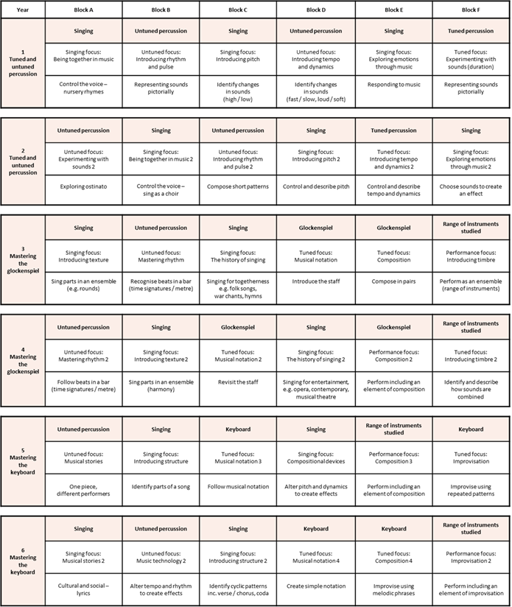

If you would like further information about the progression of skills within our curriculum, please contact the Music Subject Leader.

Teaching and learning: We use the CUSP curriculum because …

CUSP Music resources contain a wealth of evidence-led materials to support excellent teaching and long-term learning.

INSERT IMAGE A

Outcomes as a result of the curriculum, teaching and learning ​
Samples of our pupils’ learning: (School inserts examples of pupil outcomes in books – range of ages)

How the Subject Leader monitors and evaluates the curriculum:
We use Pupil Book Study (Alex Bedford, published by John Catt) to evaluate the impact of the curriculum on the lived experience of pupils.
(School inserts how they monitor and evaluate the curriculum)

